**CRITICAL PATH ANALYSIS AND PERT CHART**

TASK LIST:

|  |  |  |
| --- | --- | --- |
| S.NO | TASK | DEPENDENT |
| 1 | High level Analysis |  |
| 2 | Selection of hardware platform | 1 |
| 3 | Detail analysis of core module | 1 |
| 4 | Programming for core modules | 3 |
| 5 | Quality Assurance for core modules | 4 |
| 6 | Core module training | 2,5 |
| 7 | Deployment | 5,6 |

PERT CHART:

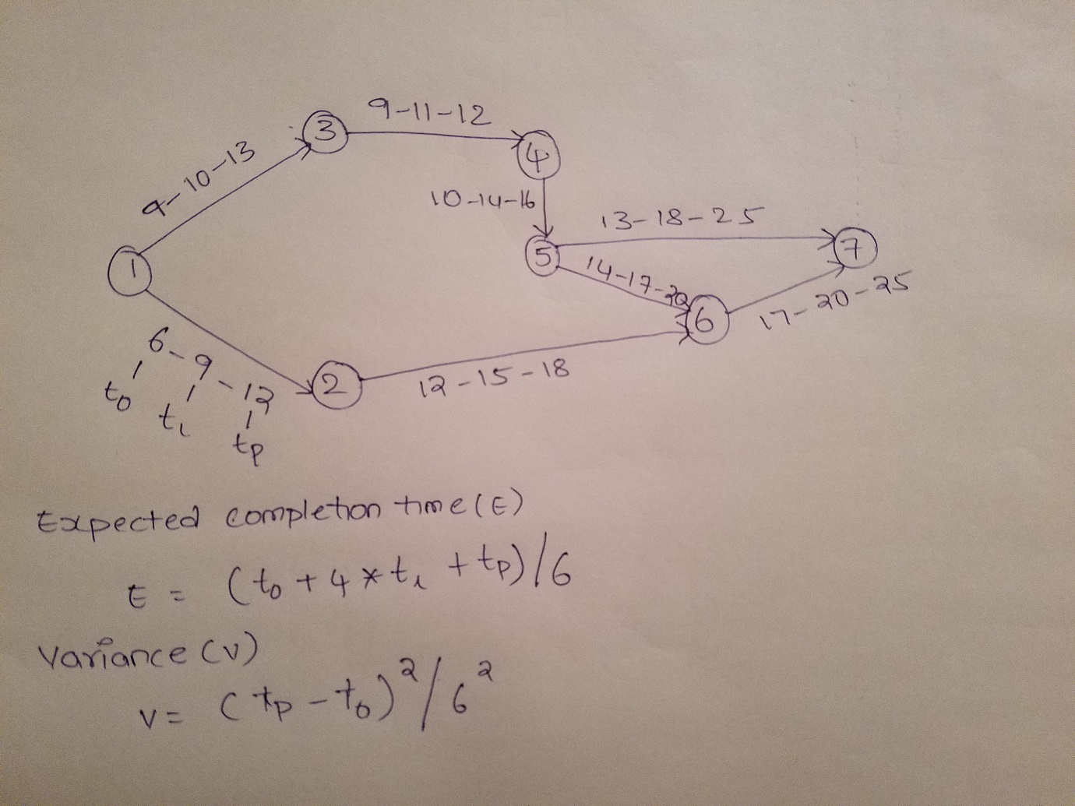

|  |  |  |  |  |  |  |
| --- | --- | --- | --- | --- | --- | --- |
| S.NO | Activity | Optimistic(to) | Most likely (tl) | Pessimistic(tp) | Variance(V) | Expected Completion Time(E) |
| 1 | 1-2 | 6 | 9 | 12 | 1 | 9 |
| 2 | 1-3 | 9 | 10 | 13 | 1 | 10 |
| 3 | 2-6 | 12 | 15 | 18 | 1 | 15 |
| 4 | 3-4 | 9 | 11 | 12 | 0.25 | 10.8 |
| 5 | 4-5 | 10 | 14 | 16 | 1 | 18.66 |
| 6 | 5-6 | 14 | 17 | 20 | 1 | 17 |
| 7 | 5-7 | 13 | 18 | 25 | 4 | 18.3 |
| 8 | 6-7 | 17 | 20 | 25 | 1.78 | 20.33 |